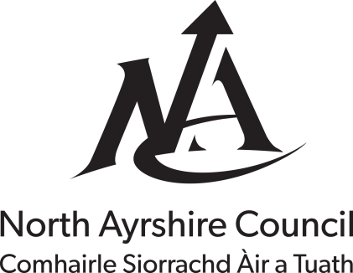

Explanatory Leaflet for Council Tax Discount for Members of a Religious Community

When counting the number of adult residents in a property members of a religious community may be excluded.

When after excluding members of a religious community, there is only one person resident in the house the Council Tax and water service charges will be reduced by 25%. Where all residents are members of a religious community the Council Tax and water services charges will be reduced by 50%.

The definition of a member of a religious community is –

A person who is a member of a religious community, the principal occupations of which consist of two or more of the following:
• Prayer
• Contemplation
• Education
• The relief of suffering
and who has no income (apart from any pension from previous employment) or capital of their own (if you own your home this would be deemed as capital), and is dependent on the community for their material needs.

To apply for a discount or exemption please provide the information requested overleaf, sign the declaration and return the form to the address shown below, together with supporting evidence.

If you qualify for a discount we will send you a replacement Council Tax bill showing the reduced sum due. If the claim is unsuccessful or we require further information we will contact you.

Review of the Discount

The discount will continue providing the qualifying criteria are being met. However, North Ayrshire Council will conduct a review of the circumstances each year by contacting you
by telephone or email. If at any time you believe the reduction no longer applies then you must contact the Council immediately.

Do you need Help with this Form?

If you have any questions regarding this application please telephone 01294 310000 from 08.30am to 05.30pm Monday to Friday. You can also visit the public enquiry desk at Bridgegate House, Irvine from 09.00am to 04.45pm Monday to Thursday and 09.00am to 04.30pm on a Friday or use the Contact Us facility on the Council's web site.

Council Tax Reference No.

- Please supply the following information in case we need to contact you regarding this application.

Daytime Telephone No.

Evening Telephone No.

E-Mail Address

- Section 1 : To be completed by the person liable for Council Tax

What is your full name?

What is the full address including postcode of the property?

What is your full postal address including postcode for correspondence?
(if different from above)
Do you pay rent on the property or is it paid on your behalf?

Please indicate the number of persons 18 years of age or over usually resident in the house?

Please give the full names of all the residents over the age of 18 who are members of the religious community?

- Section 2 : To be completed by the Head of the Religious Community

Name of Religious Community

Date Applicant(s) joined Religious Community

I can confirm that the applicant(s) is/are a member of this Religious Community and has / have no income (apart from any pension from previous employment) or capital and is / are dependant on the community for their material needs.

Signature of Head of Religious Community | Signed:………………………………….  Position:…………………………………  Date:…………………………………….

Documentary Evidence

Please attach in support of this application the following documentary evidence-

- A statement outlining the Objectives of the Religious Community

- To be completed by the person liable for Council Tax

Declaration
I declare that the information I have given in this form is correct and complete and I agree to notify you immediately of any changes that might affect my council tax.

I understand that the deliberate provision of false information in order to achieve financial gain is a Criminal Offence and you may check the information with other sources as allowed by the law.

I understand that any information I have provided will be used in the administration of my council tax account. You may give information to other parties if the law allows this.

Signature of liable person

Date

What do you think?

We value the opinions of our customers. This form has been designed to be in plain, jargon free language however, if you find any of the sections difficult to understand or complete please let us know by completing the suggestion box at the end of the form

Was the form easy to complete? | Yes No  If you answered No please give details:
Was the form easy to understand? | Yes No  If you answered No please give details:
Was there any information not included on the form which you would like to see included?
Do you have any suggestions on how the form could be improved?

