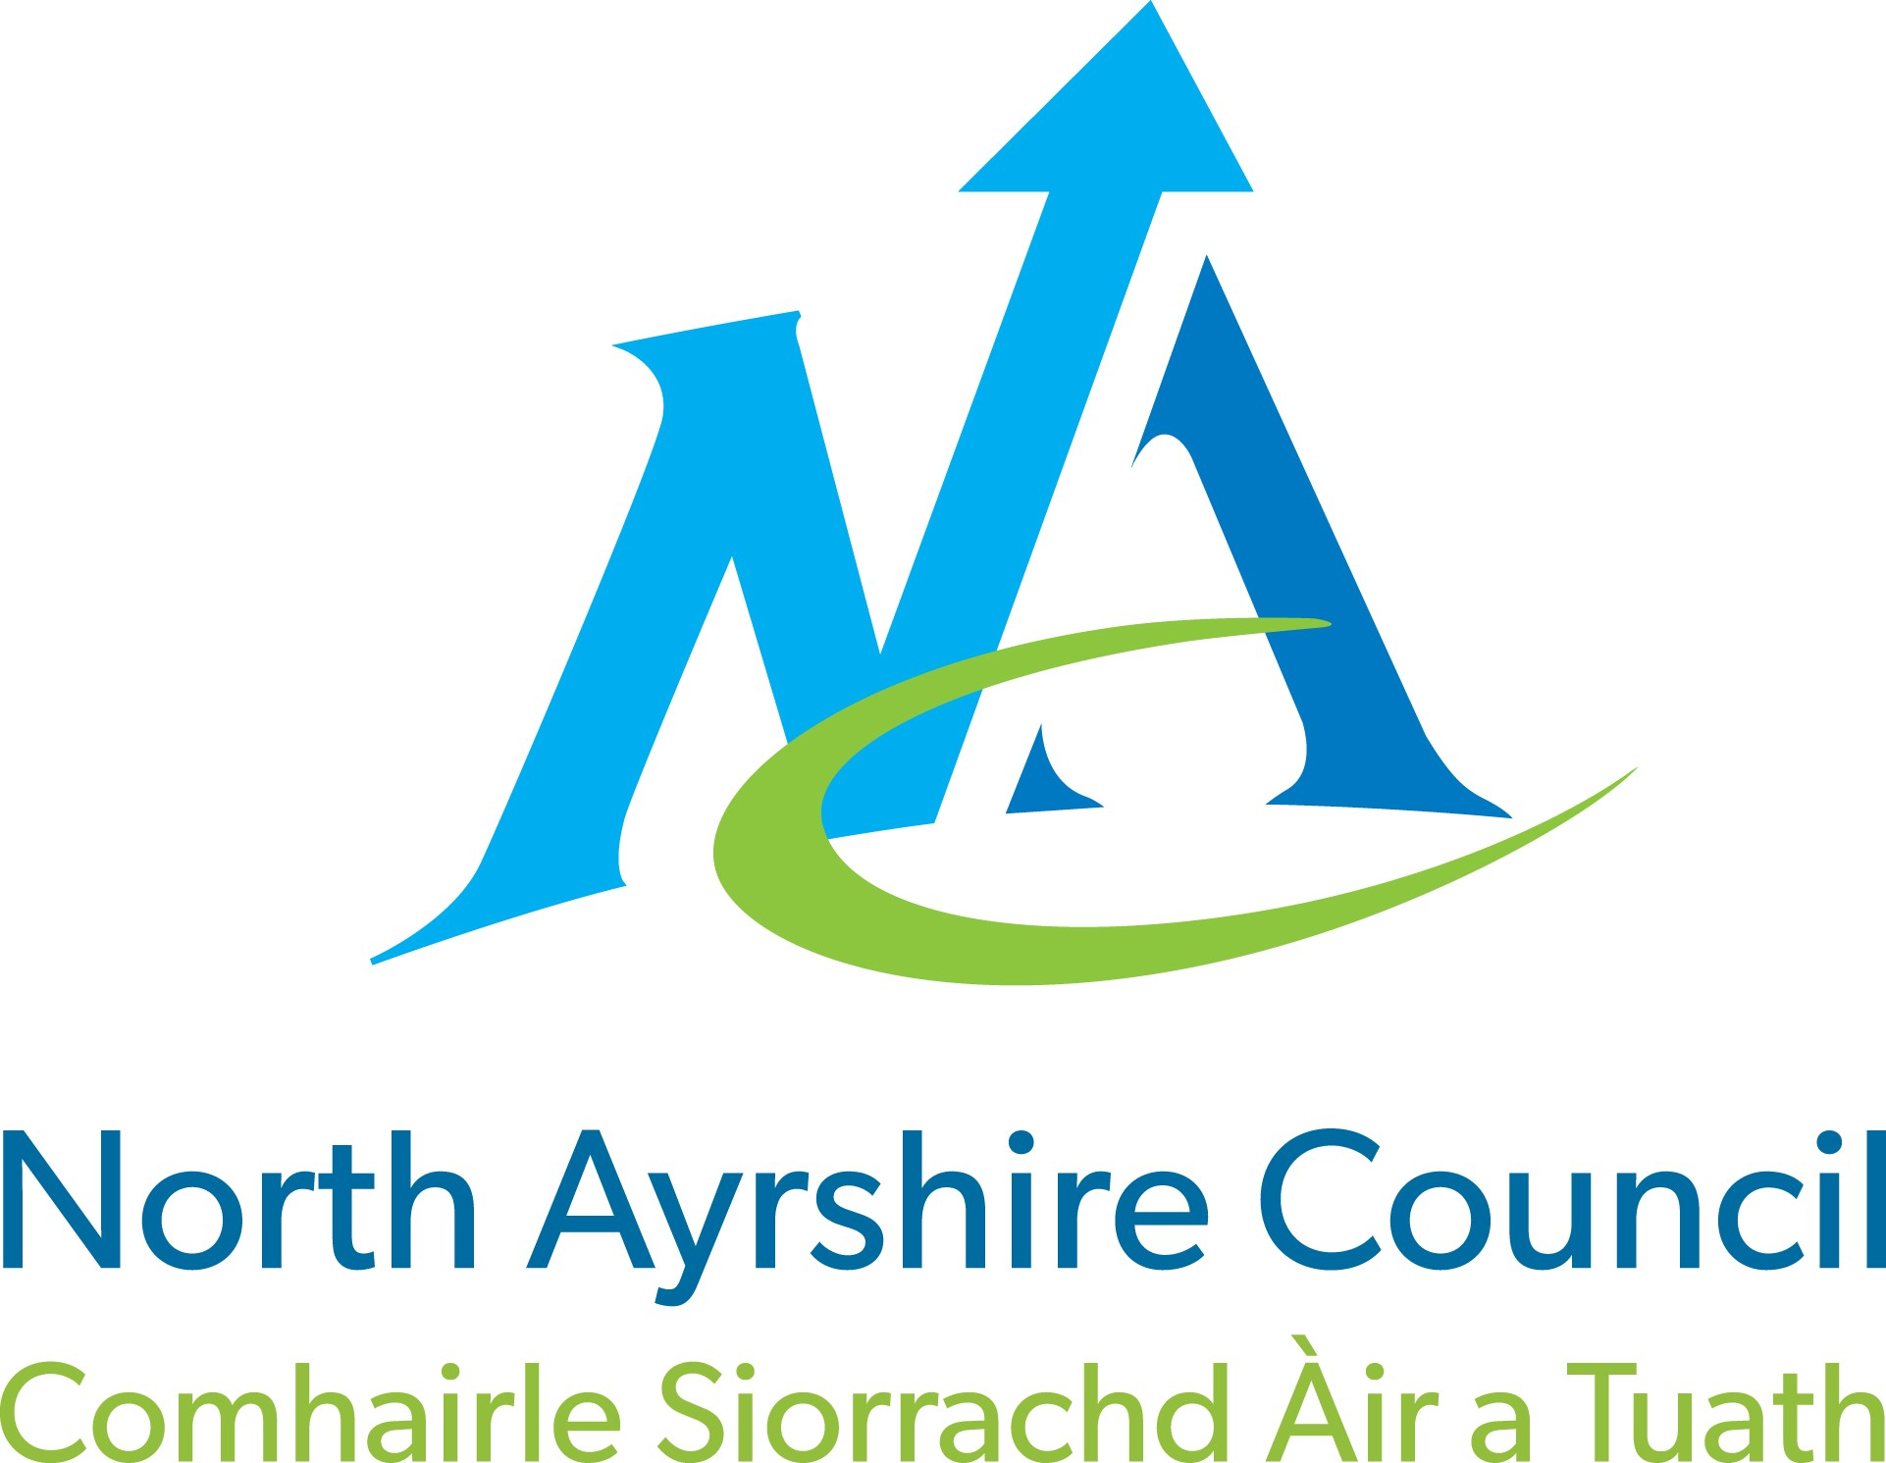

HOUSEHOLD WASTE RECYCLING CENTRES

Application for

Vehicle/Trailer Access Permit

*= Mandatory Information

Applicant Details

*Title (Mr/Mrs/Miss/Ms) ………… *Surname …………………………….
*First Name |  | …………………………………………
*Address |  | …………………………………………
*Town |  | …………………………………………
*Post Code |  | …………………………………………
*Telephone No |  | …………………………………………
Email Address |  | …………………………………………

Note: Height restriction barriers of 6'3" (1.9m) apply to all sites. Vehicles over 3500kg will not be allowed on site.

Hired Vehicle Details (if applicable)

*Hire Company: ……………………………………….........

*Length of Hire Agreement; From……………. To:…………………..

Please provide the vehicle details
*Type: (Select) | Car & Trailer / Van / Van & Trailer / Pick-Up / Pick-up &  Trailer / Mini-bus (8-11 seats) / Mobility Vehicle over 6’3”  (1.9m) in height
*Make: | ……………………………………………….
*Model: | ………………………………………………..
*Colour: | ………………………………………………..

*Registration No: ………………………………………………..

*Gross Vehicle Weight………..………………………………………….
(See your Vehicle Registration Document)

* Does the vehicle have a company logo? YES / NO
(If yes, an authorisation letter is required from the company allowing private use for transporting your household waste)

Registered Keeper Details
(If different from applicant’s details)

*Title (Mr/Mrs/Miss/Ms) ………… *Surname …………………………
*First Name | …………………………………………
*Address | …………………………………………
*Town | …………………………………………
*Post Code | …………………………………………  Trailer Details – (if applicable)
Single Axle Trailer

Please note double axle (4 wheel) trailers are not allowed on site.

Declaration
The vehicle is not used in a commercial capacity of any nature. Any permits issued shall remain the property of North Ayrshire Council and may be withdrawn at any time. A permit will not guarantee entry into a site, and site staff must be satisfied that the waste for disposal is domestic. All rules and regulations in place at the site must be adhered to at all times.
A permit is valid for one year from the date of issue, and it is the permit holder’s responsibility to renew it. Exemption Permits for mobility vehicles exceeding the height restriction are valid until the expiration date of the applicants Blue Badge. Lost/stolen permits cannot be replaced.
By signing this form I agree that all information provided is correct and I agree with the statement above.

Print Name: | ……………………………………………………………………
Sign: | ……………………………………………………………………
Date: | ……………………………………………………………………

IMPORTANT

Supporting Documents – Checklist

Please send photocopies of these with your application form.

Please DO NOT send original documents.

- Vehicle Registration Form V5/V5-C (Log book)
- An authorisation letter for private use of a company vehicle for the disposal of your household waste. (if applicable)
and
- Your North Ayrshire Council Tax Letter or utility bill
- Your Blue Badge - if applicable (For mobility vehicles exceeding the height restriction only)

Any applications received without the supporting documentation will be rejected. The vehicle must be registered and insured in your name and not that of a business unless you have an authorisation letter allowing you to use the vehicle to dispose of your household waste. Householders hiring a commercial type vehicle are required to bring their hire agreement to the site they intend to visit along with their permit.

Conditions of issue
- For use only by residents of North Ayrshire.
- Permits are valid for 12 months and allow the use of the site up to 12 times during that period. For more than 12 visits within the year, residents must reapply with further information.
- Proof of identity / residency will be required.
- Exemption Permits may be issued to mobility vehicles that exceed the height restriction and will be valid until the expiration date of the applicants Blue Badge. Ordinary vehicles such as cars and small 4x4’s which exceed the height restriction because of a roof box must apply for an exemption.
- Permits are not transferable.
- Residents hiring a commercial type vehicle for household waste must apply for a one off permit. This will allow a maximum of 3 visits. • Permits valid only for the vehicle described overleaf.
- Permit will not be issued for vehicles over 3500kg gross weight.
- The site attendants reserve the right to refuse access to the site if it is suspected that the waste is commercial in origin (issue of a permit does not give automatic right to tip).
- No trade waste is allowed at any of North Ayrshire’s Household Waste and Recycling Centres.
- Only domestic waste from your own property is allowed.
- Double axle trailers are not allowed on site.
- Automatic Number Plate Recognition and CCTV are in operation at these sites. Information collected by ANPR will be used for monitoring access to the sites, and it may be shared with other organisations for the purpose of investigating breaches of waste regulations and the prevention and detection of crime. North Ayrshire Council reserves the right to refuse or cancel the issue of permits if provided with false or misleading information.

Should you require any further help or advice, please contact us on
01294 310000

Please send the completed form along with copies of the required documents to:

Business Support - Tip Permits
North Ayrshire Council
3rd Floor West Cunninghame House
Friars Croft
Irvine
KA12 8EE

